**Ministry Of International Intelligence Gathering (MOINIG) War Request Form**

**MOINIG Contact Information:**

Address: MOINIG HQ, Everwick, Deira

Email: compliance@moinig.da

Date: *25/10/2024*

**Requester Information:**

Full Name: *Emperor Llewyn*

Email Address: *emperor@senate.gov.ct*

Mailing Address:

*The Grand Imperial Palace*

*1 Imperial Way*

*Llewton*

*Cait*

**Request Details:**

Please specify the type of war you are requesting (check all that apply):

[ ] Conquest

[ ] Cold war

[X] Nuclear war

[X] Pineapple war *(not mandatory, but sounds like it could be fun)*

[ ] Other (please specify): _______________________________

**Purpose of Request:**

Please briefly explain the purpose of your request:

*I, Emperor Llewyn, First Authority of Cait, wish to declare full-scale nuclear war upon the Kingdom of Deira for refusing to provide necessary information pertaining to your attempted assassination of the President of the Republic of Rheged.*

**Verification:**

To process your request, please provide a copy of an issued ID to verify your identity. Additional documentation may be required based on the nature of your request.

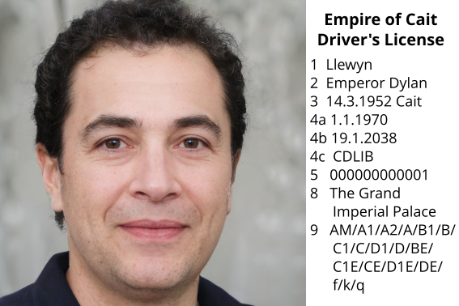

**Additional Verification Details:**

Please fill in the following additional details for verification. We cannot continue without answers.

Place of birth: *Cruithne, Cait*

Time of birth: *14/3/1952* 0*6:53:58*

Star sign: *Aries*

Sun sign: *Pisces*

Population within 12 miles of birth at date of birth: *1,945*

Population within 12 miles of birth yesterday: *513,954*

Hospital of birth: *The People’s Hospital of Cruithne*

*Please note that we cannot process requests for individuals born at home or otherwise outside of a hospital*

Passport number of next individual born at hospital: 27182818284

Details of dead drop with £$500: Left with the receptionist (nice lass)

Primary email service: *senate.gov.ct*

Password to primary email service: Passwo0rd!

Secondary email service: whale.mail

Password to secondary email service: LlewynLaughs4Days!

Opinion on pineapples: Good on pizza (suggesting pinapples are good on pizza will be met with imidate nuclear annihilation)

**Additional security questions:**

Have you ever committed a terrorist attack: No

Please disclose to greatest extent of your cartel involvement: None

Are you a dictator: Yes

If yes, what’s your bank balance: Yes

If no, when do you plan to become: N/A

Have you ever committed genocide: Not in my opinion.

Please complete and submit this form adequately within 10 minutes, otherwise another form will need to be sent.

**Signature:**

By signing below, I confirm that the information provided in this request is accurate and that I am the individual to whom the data pertains.

Signature: *Llewyn*

Date: *01/11/2024*

**Submission Instructions:**

Please submit this form along with any required documentation to MOINIG via the contact information provided above. Due to the sensitive nature of the information, responses may take longer than standard processing times.

**Important Note:**

Requests for access to information may be subject to national security considerations and may not be fulfilled if the information is classified or if disclosure would compromise national security.